**AGRICULTURAL ROBOTICS**

1. **Abstract: -**

One of the major economic issues faced by the country is agriculture as this is the sector which is source of livelihood for about 54% of Indians till date. Still today this sector is not well developed and faces lots of problems resulting into low productivity of crops. The rural farmers in India suffer from poverty and most of them are illiterate so there is lack of good extension services like on time sufficient electricity, high cost for different modern techniques and lack of human power. For six decades robots have played a fundamental role in increasing the efficiency and reducing the cost of industrial production and products. In the past twenty years, a similar trend has started to take place in agriculture, with tractors and harvesters already being available commercially but all this take more cost that is not preferable for poor farmer and a required-on time electricity is not available for sprinkling. So, we tried to solve this problem through robotics. Our robot is energy saving and efficient as it contain solar plate on it and can perform plough, sowing seed and sprinkling. It contains a wireless camera, and we can control a robot from some distance. In agricultural robotics, as in other robotic systems, one of the most important parts is the control architecture.

1. **Introduction: -**

An agricultural robot capable of performing farming like ploughing, seeding, sprinkling. It contain a wireless control through computer. It makes robot work efficient and effective. This controls required a separate system to use so we use a RF module technology. Therefore, a transmitter and transceiver are used respectively at laptop and on robot. Robot is authenticated by User id and password for accessing its GUI. An alternative of “Voice Passwords” for starting the robot vehicle will be also implements as security requirement increased. The system concentrates on ‘Farming’. If a driver gives correct user id and password, then vb button format allows him to start the robot vehicle perform farming activity and stop. In order a ploughing and seeding is perform by command given through computers VB button format GUI. We are also using wireless camera which gives an actual view of field. It can also use in another manner like to detect suspicious activities for entering the farm by other individuals. The next main feature ‘solar energy’ includes the flexibility in system by use of solar energy in charging the battery. It leads the use of robot in critical situations like shortage of electricity.

1. **Background: -**

The rural farmers in India suffer from poverty and most of them are illiterate so there is lack of good extension services like on time sufficient electricity, high cost for different modern techniques and lack of human power. For six decades robots have played a fundamental role in increasing the efficiency and reducing the cost of industrial production and products. In the past twenty years, a similar trend has started to take place in agriculture, with tractors and harvesters already being available commercially but all this take more cost that is not preferable for poor farmer and a required-on time electricity is not available for sprinkling. So we tried to solve this problem through robotics. These robots are energy saving and efficient as it contains solar plate on it and can perform plough, sowing seed and sprinkling. It contains a wireless camera, and we can control a robot from some distance. In agricultural robotics, as in other robotic systems, one of the most important parts is the control architecture.

1. **Applications of agriculture robots: -**

Agricultural robots automate slow, repetitive and dull tasks for farmers, allowing them to focus more on improving overall production yields. Some of the most common robots in agriculture are used for:

* Harvesting and picking
* Weed control
* Autonomous mowing, pruning, seeding, spraying and thinning
* Phenotyping
* Sorting and packing
* Utility platforms

Harvesting and picking is one of the most popular robotic applications in agriculture due to the accuracy and speed that robots can achieve to improve the size of yields and reduce waste from crops being left in the field.

These applications can be difficult to automate, however. For example, a robotic system designed to pick sweet peppers encounters many obstacles. Vision systems have to determine the location and ripeness of the pepper in harsh conditions, including the presence of dust, varying light intensity, temperature swings and movement created by the wind.

But it still takes more than advanced vision systems to pick a pepper. A robotic arm has to navigate environments with just as many obstacles to delicately grasp and place a pepper. This process is very different from picking and placing a metal part on an assembly line. The agricultural robotic arm must be flexible in a dynamic environment and accurate enough not to damage the peppers as they’re being picked.

Harvesting and picking robots are becoming very popular among farmers, but there are dozens of other innovative ways the agricultural industry is deploying robotic automation to improve their production yields.

The demand for food is outpacing available farmland and it’s up to farmers to close this gap. Agricultural robots are helping them do just that.

Agriculture has quickly become a high-tech business. If you want to learn more about emerging robotics industries, join companies like Amazon, Microsoft and GM at the annual [A3 Business Forum](https://www.a3automate.org/a3-business-forum/?__hstc=102377502.16deed4623e393a14a29dc3d33caecf2.1612102512888.1612102512888.1612102512888.1&__hssc=102377502.1.1612102512889&__hsfp=1229161931) to network with leaders in the automation industry.

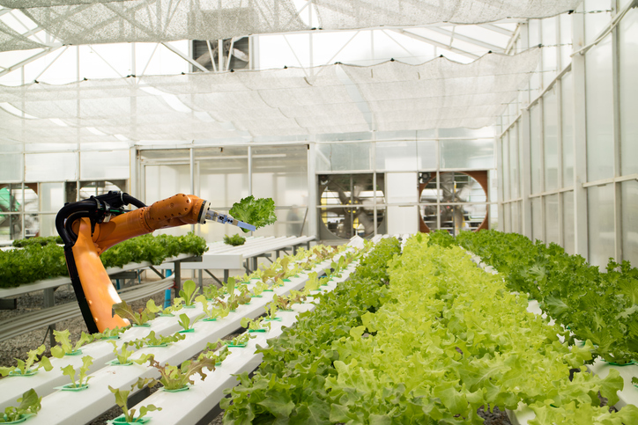 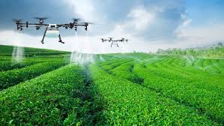

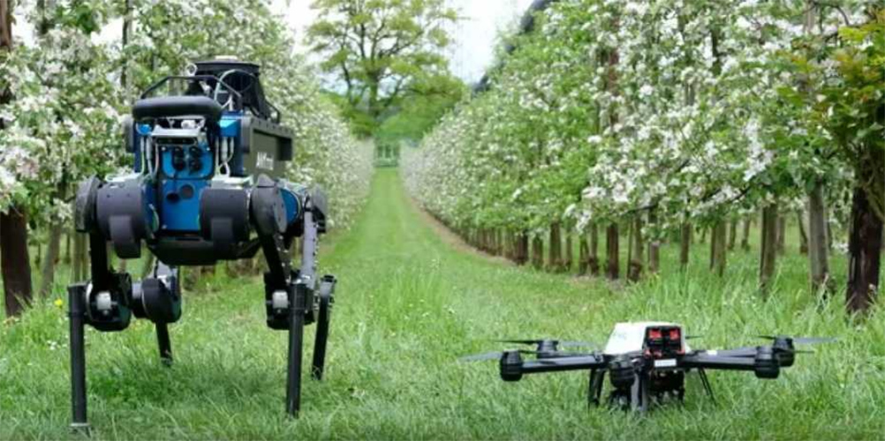

1. **Methods and Equations: -**

Here we are going to discuss one of above-mentioned robots and the method of making these robots. The useful RF transmitter and trans receiver were analysed and hardware designing based on embedded system were detailed. For short distance transmission, controlling signals sends and receives using radio frequency communication. The proposed system have abroad application foreground in the real application field.

1. PC CONTROLLED AGRICULTURAL ROBOT which is wireless control.
2. Today’s major problem that is shortage of electricity is also get a solution in it.
3. **Flow chart: -**

Start

Turn on the GUI

Commands GOTO the

Transmitter for Transmission

Trans receiver receives

Command

MAX232 convert the logic

Into TTL / CMOS

Sends to Microcontroller

Microcontroller send to

Motor Driver

Starts the DC Motor

According to Command

Stop

1. **Conclusion: -**

All in one is the best quality for every machine. Efforts must be getting decrease but intelligently Without effecting the output. As always machine depends on its resources, but we need to implement machine in such a way that it produces its resources by itself.